The Greene County Church Dartball League
would like to thank the following for making our
Award Ceremony a success:

First Baptist Church of Waynesburg

Catering

Penncraft Market, East Millsboro, PA

Trophies & Awards

Tri-State Designs, Claysville, PA



77th ANNUAL

GREENE COUNTY

CHURCH DARTBALL LEAGUE

AWARD CEREMONY

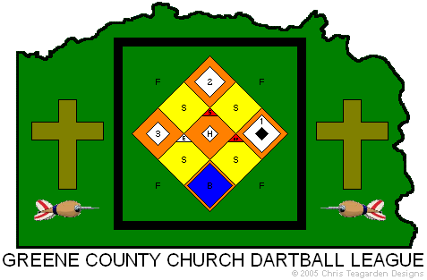

First Baptist Church of Waynesburg
Waynesburg, Pennsylvania
Monday, April 15, 2024 – 6:30 pm

If we walk in the light, as he is in the light,
we have fellowship one with another.
1 John 1:7

THIS EVENING’S PROGRAM

WELCOME

INVOCATION

DINNER

IN MEMORIAM

PRESENTATION OF AWARDS

BENEDICTION

Thank you to every individual who participated in making our 77th season another great year! A special thank you to every church that allowed us the use of their facility for the games. Thanks to our fine officers for their time devoted to the league. And thanks to our Team Managers for all their hard work. We look forward to kicking off the 78th season in late August/early September!

LEAGUE INFORMATION

Website

gcdartball.50webs.com

Facebook

Facebook.com/groups/GreeneDartball

Email

greenedartball@gmail.com

ANNUAL SPRING TOURNAMENT

Trophies are also awarded to the All-Tournament Team,

Which include the best overall batting average in round-robin play,

as well as the top six male and top three female batting averages.

All-Tournament Team

Most Valuable Player

Eric Russman - .684

Men

Greg Deter (Greensboro Baptist) - .676

Phil Westich (Bible Baptist) - .621

Jason Bard - .615

Mark Burd - .609

Tim Tanner (Greensboro Baptist) - .588

James Baker (Jefferson Baptist #1) - .581

Women

Hannah Shingle - .571

Amy Brownfield (Oak View Methodist) - .567

Wendy VanRiper - .423

ANNUAL SPRING TOURNAMENT

Our annual league fundraising tournament was held on

Saturday, March 2 at the Marianna Volunteer Fire Department.

This year’s tournament featured 23 teams from numerous

dartball leagues in southwestern Pennsylvania. Thanks to
Crosspoint VBS for providing the concession stand!

Tournament Champion

“Black’s Insurance”

(Washington Area Church Dartball League)

Tournament Runner-Up

“Fireball Buddies”

(Washington County Arden League)

B-Division Champion

“Greensboro Baptist”

(Greene County Church Dartball League)

Greg Deter, Ricky Deter, Tim Tanner, Tim Tanner, Jr.

B-Division Runner-Up

“Rooks”

(Washington County League)

2023-2024 BY THE NUMBERS

174

There was a total of 174 players this season. That’s an average of over 13 players for each of our 13 teams!

401

Greensboro Baptist was the highest scoring offense this season. That averages out to 6.08 runs per game!

212

Crabapple Community had the stingiest defense in the league. They only surrendered 3.21 runs per game!

56

The Week 4 matchup between Bible Baptist and Jefferson Baptist #2 was the highest scoring match of the season! Bible Baptist won all three games, by scores of 7-6, 12-5, and 18-8!

69

The number of players 55 years of age and older, representing 40% of our league!

77

Our league has been going strong since 1946. That’s 77 years of fun, fellowship, and great dartball!

2023-2024 FINAL STANDINGS

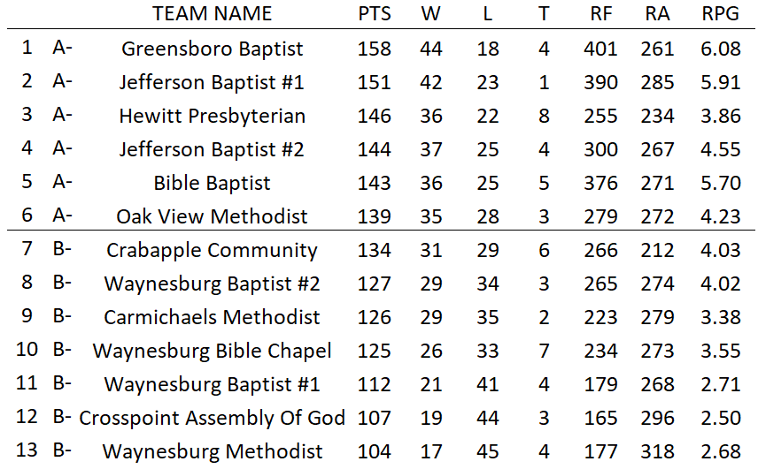

2023-2024 LEAGUE OFFICERS

Chairperson – James Baker
Treasurer – Ryan Brownfield
Secretary – Phil Westich

Statistician/Tournament Director – Adam Brewer
Asst. Tournament Director – John “Buck” Buchanan

LEAGUE PRESIDENTS/CHAIRPERSONS

1947-1948 J. Bell 1949 W. Maxwell
1950 A. Titus 1951 F. Orndorff
1952 O. Fox 1953 E. Cole
1954 A. Hudson 1955 W. Van Scyoc
1956 R. Corwin 1957 W. Acklin
1958 Dr. J.H. Stewart 1959 S. Lohr
1960 H. Grandon 1961 A. Varner
1962 J. Zimmerman 1963 A. Clayton
1964 G. Lippencott 1965 W. Curtis
1966 G. Robinson 1967 F. Patterson
1968 A. Turner 1969 E. Cole
1970 P. Lohr 1971 L. Daugherty
1972-1973 J. Conklin 1974 K. Oakes
1975 C. Phillips 1976 E. Bennett
1977 G. Stiles 1978 E. Modrick
1979 C. Shaw 1980 R. Mitchell
1981 R. Zimmerman 1982 J. Buchanan
1983 D. Shaw 1984 E. Smith
1985 G. Handford 1986 R. Post
1987 B. Hawk 1988 C. Orndorff
1989 R. Reynolds 1990 D. Tennant
1991 C. Moon 1992 R. Conner
1993 D. Grimes 1994 J. Roberts
1995 J.B. Humble 1996 G. Doutt
1997 G. Chernisky, Jr. 1998-2000 D. Grimes
2001-2011 J. Sands 2012-2013 J. Chahl, III
2014-2019 C. Teagarden 2020-2022 C. Sands
2023 A. Juliani 2024 J. Baker

LEAGUE CHAMPIONS

1947 – Waynesburg Christian 1948 – Waynesburg Methodist
1949 – Waynesburg Baptist 1950 – Waynesburg Methodist
1951 – Waynesburg Baptist 1952 – Waynesburg Methodist
1953 – Waynesburg Methodist 1954 – Waynesburg Methodist
1955 – Waynesburg Baptist 1956 – Waynesburg Baptist
1957 – Waynesburg Baptist 1958 – Waynesburg Baptist
1959 – Bethlehem Baptist 1960 – Bethlehem Baptist
1961 – Waynesburg Baptist 1962 – Bethlehem Baptist
1963 – Bethlehem Baptist 1964 – Bethlehem Baptist
1965 – Bethlehem Baptist 1966 – Bethlehem Baptist
1967 – Bethlehem Baptist 1968 – Bethlehem Baptist
1969 – Bethlehem Baptist 1970 – Bethlehem Baptist
1971 – Waynesburg Baptist 1972 – Bethlehem Baptist
1973 – Bethlehem Baptist 1974 – Bethlehem Baptist
1975 – Bethlehem Baptist 1976 – Bethlehem Baptist
1977 – Bethlehem Baptist 1978 – Spraggs Methodist
1979 – Bethlehem Baptist 1980 – Waynesburg Baptist
1981 – Waynesburg Baptist 1982 – Waynesburg Baptist
1983 – Waynesburg Baptist 1984 – Waynesburg Baptist
1985 – Waynesburg Baptist 1986 – Waynesburg Baptist
1987 – Waynesburg Baptist 1988 – Waynesburg Baptist
1989 – Throckmorton Methodist 1990 – Waynesburg Baptist
1991 – Masontown Presbyterian 1992 – Masontown Presbyterian
1993 – Masontown Presbyterian 1994 – Throckmorton Methodist
1995 – Carmichaels Methodist 1996 – Ambassadors For Christ “A”
1997 – Throckmorton Methodist 1998 – Carmichaels Methodist #1
1999 – Carmichaels Methodist #1 2000 – Carmichaels Methodist #1
2001 – Carmichaels Methodist #1 2002 – Carmichaels Methodist #1
2003 – Carmichaels Methodist #1 2004 – Ambassadors For Christ
2005 – Ambassadors For Christ 2006 – Ambassadors For Christ
2007 – Throckmorton Methodist 2008 – Fairall Methodist
2009 – Fairall Methodist 2010 – Throckmorton Methodist
2011 – Throckmorton Methodist 2012 – Fairall Methodist
2013 – Washington Street Methodist 2014 – Washington St. Methodist
2015 – Washington Street Methodist 2016 – Jefferson Baptist
2017 – Fairall Methodist #1 2018 – Jefferson Baptist
2019 – Hewitt Presbyterian 2020 – Greensboro Baptist #1
2022 – Greensboro Baptist 2023 – Greensboro Baptist
2024 – Greensboro Baptist

LEAGUE CHAMPIONSHIP PLAYOFFS

Quarterfinals (March 18)

#3-Hewitt Presbyterian – 3 vs. #6-Oak View Methodist – 0

#5-Bible Baptist – 3 at #4-Jefferson Baptist #2 – 0

Semifinals (March 25)

#1-Greensboro Baptist – 3 vs. #5-Bible Baptist -– 2

#2-Jefferson Baptist #1 – 3 vs. #3-Hewitt Presbyterian – 0

Championship (April 1)

#1-Greensboro Baptist – 3 vs. #2-Jefferson Baptist #1 – 2

B-DIVISION PLAYOFFS

Quarterfinals (March 18)

#8-Waynesburg Baptist #2 – 3 vs. #13-Way. Methodist – 2

#10-Way. Bible Chapel – 3 vs. #11-Way. Baptist #1 – 0

#12-Crosspoint Assy. Of God – 3 at #9-Carm. Methodist - 1

Semifinals (March 25)

#7-Crabapple Community – 3 vs. #10-Way. Bible Chapel – 0

#8-Way. Baptist #2 – 3 vs. #12-Crosspoint Assy. of God - 1

Championship (April 1)

#8 Way. Baptist #2 – 3 at #7-Crabapple Community – 0

2023-2024 TEAM TROPHIES

Regular Season Champion – Greensboro Baptist
League Champion – Greensboro Baptist
League Runner-Up – Jefferson Baptist #1
B-Division Champion – Waynesburg Baptist #2
B-Division Runner-Up – Crabapple Community

TEAM LEADERS BY CATEGORY

Highest Batting Average – Greensboro Baptist – .366
Best Slugging Percentage – Bible Baptist – .59421
Most RBI's – Greensboro Baptist – 401
Most Total Bases – Jefferson Baptist #1 – 1536
Most Hits – Greensboro Baptist – 948
Most Singles – Greensboro Baptist – 680
Most Doubles – Crosspoint Assembly Of God – 206
Most Triples – Jefferson Baptist #1 – 259
Most Home Runs – Carmichaels Methodist – 91
Most Long Singles – Greensboro Baptist – 36

HALL OF FAME

(BOLD indicates new inductee)

Kyle Lawrence Donald “Duck” Lemley Jason Lemley
Jenny Lemley Jesse Lint Guy Lippencott
Bill Logan Virginia Logan Ron Lohr
Ray Mallory Albert Mariner Dolores McCracken
Brian Mehalovich Matt Mehalovich Dwight Mitchell
Gene Mitchell Jack Mitchell Robert Mitchell
Tim Mitchell Jeff Mooney Kay Mooney
Bob Moore Amie Deter Nehls Kempton Oakes
Cassie Orndorff Christy Orndorff Corbly Orndorff
Oscar Phillips Sam Phillips Bob Post
Freda Pyle Christian Randolph Paul Reggetz
Alberta Renner Bob Reynolds Deb Reynolds
Paul Rhodes Eric Rhome Forest Rhome
Ivan Robinson, Jr. Ivan “Bud” Robinson, III John Robinson
Chas Sands Jim Sands Clyde Shaffer
Otis “Buck” Shaffer Dave Shaw Lanfer Simpson
Gary Stiles Morris Strawn Andy Swestyn
Bob Swestyn Matthew Tanner Terrie Tanner
Tim Tanner Tim Tanner, Jr. Chris Teagarden
Rachie Teegarden Donnie Tennant Jason Tennant
Larry Thomas Dennis Tucker Nicole Tucker
Warren Van Scyoc Brittany Vogel Mary Walker
Bertram Waychoff Challen Waychoff Charles Weaver
Jeff Weaver Jeff Wehrle Bethany Westich
Daniel Westich Julia Westich Nathan Westich
Pat Westich Philip Westich Stephen Westich
Charles Whipkey Sandy Whipkey Charles White
Cliff Whyte Clyde “Butch” Whyte Jerry Wilson
Jennifer Wolfe TIFFANY WOLFE Jim Wood
Cathy Yenchik Lori Yenchik George Zentkovich
Jim Zimmerman

HALL OF FAME

(BOLD indicates new inductee)

Bud Adamson Don Amon Bill Ankrom
Brandi Baker James Baker Jeremy Baker
Joseph Balaban Rita Balaban Bob Bates
Robert Bell Earl Bennett Mearl Black
Jack Blair Tommy Bohan Danielle Bowlen
Doris Braun Jim Broderick Ryan Brownfield
TODD BROWNFIELD Butch Brunell JOHN BRUNO
Angela Buchanan John “Buck” Buchanan Roy Buchanan
Earl Byard Lydia Westich Calix Carlton “Tom” Calvert
Ray Campbell Rich Cappuzzi Delmas Carpenter
Patty Carpenter Joe Carroll Albert Cathers
Bill Chahl Joanna Westich Chahl John Chahl, III
Sam Chahl Dorothy Cheek George Chernisky, Sr.
George Chernisky, Jr. Earl Cole Minor Cole
Bob Colley Joe Conklin Karen Coursin
Jeff Cree Al Danley Betty Davis
Ray Davis Bill DeBolt Jane DeBolt
Butch Deter Craig Deter Greg Deter
Rick Deter, Sr. Rick Deter, Jr. Tom Dorazio
Kathy Douglas Greg Doutt Scott Durr
Jim Durst George Ealy Ralph Earley
Charles Eddy Barry Elliott Bob Ellsworth, Sr.
Calvin Fenton Ollie Fox Bob Fuller
Jim Garber Mark Garrison Lou Giachetti
Herb Grandon NANCY GREENWOOD Chris Haines
Gary Hammon William Headlee MARLA HOLLAND
Ed Hollowood Carl Hoy, Jr. Donnis Hoy
Ann Johnson Howard Johnson Pete Johnson
Tom Jones Amanda Juliani Phyllis Kamerer
Tim Kelly Wayne Kennison Georgia Kiel
Caroline Kiger Doug Klescich Ed Kowalczyk

TEAM LEADERS BY CATEGORY

2023-2024

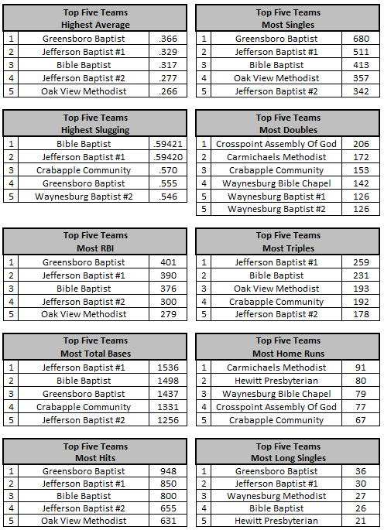

JOHN “BUCK” BUCHANAN PRESEASON

FELLOWSHIP TOURNAMENT CHAMPIONS

Tyler DiBenedetto – Carmichaels Methodist
Amanda Juliani – Carmichaels Methodist
Ray Mallory – Greensboro Baptist
Bryan Scherich – Waynesburg Methodist
Chloe Strosnider – Crosspoint Assembly Of God

CARLTON T. CALVERT MEMORIAL AWARD

Awarded to the team with the most players under age 25.
Named for the late Carlton “Tom” Calvert,
longtime member of Waynesburg Christian
and a member of the Hall of Fame.
He was an advocate for the youth movement in dartball.

Bible Baptist

Past Winners

Bethlehem Baptist (1989)
Bible Baptist (2000-02, 2005, 2007-08, 2010-12, 2022-23)
Bible Baptist #2 (2013)
Carmichaels Free Methodist (2016-2017)
Carmichaels Methodist (2020)
Clarksville Christian (1992-1996)
Fairall Methodist (1990, 2004)
Fairall Methodist #2 (2019)
Family Faith Ministries (2003-2004, 2008-2010, 2013)
Jefferson Baptist (2006, 2013-2014, 2018)
Jefferson Methodist (1986, 1997-1999)
Oak View Methodist (1987-1988, 1991, 2004-2005)
Throckmorton Methodist (2005)
Waynesburg Christian (1983-1985)
Waynesburg Presbyterian (1999)

TEAM LEADERS BY CATEGORY

FIVE-YEAR TOTALS (2019-2024)

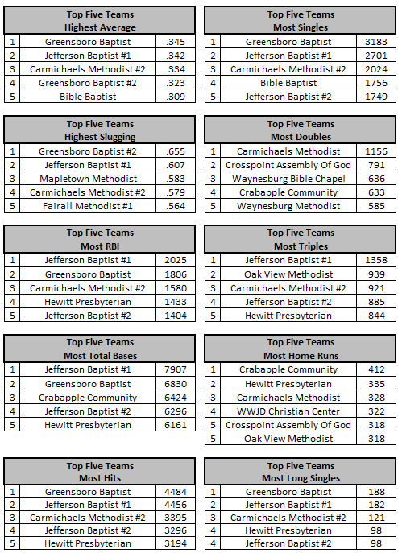

INDIVIDUAL LEADERS BY CATEGORY

FIVE-YEAR TOTALS (2019-2024)

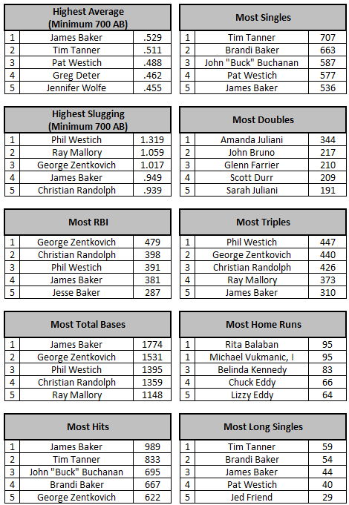
JOE CONKLIN MEMORIAL AWARD

Awarded to the team with the most senior players.
Named for the late Joe Conklin,
longtime member of Waynesburg Methodist
and a member of the Hall of Fame.

Waynesburg Bible Chapel

CARL HOY, JR. MEMORIAL

MANAGER OF THE YEAR AWARD

As voted on by team managers.
Named for the late Carl Hoy, Jr.,
longtime manager of Spraggs Methodist,
a member of the Hall of Fame,
inaugural winner and only four-time winner of the award.

Past Winners

Carl Hoy, Jr. – Spraggs Methodist (2006, 2007, 2010, 2012)
Slugger Humble – Crabapple Community (2007)
Minor Cole – Waynesburg Nazarene (2008, 2009)
Butch Deter – Throckmorton Methodist (2009)
Jerry Wilson – Jefferson Methodist (2009)
Ruth Bungard – Crabapple Community (2011, 2014)
Joe Balaban – Oak View Methodist #1 (2013)
Chris Teagarden – Carmichaels Methodist (2015, 2016)
Cliff Whyte – Fairall Methodist #1 (2017, 2019)
Charlie Hickman – Bethlehem Baptist (2018)
Ryan Brownfield – Oak View Methodist #1 (2020, 2023)
Duck Lemley – Waynesburg Baptist #1 (2022)

ROOKIE OF THE YEAR AWARD

Awarded to a first-time eligible player who has not won an individual statistic trophy and who earned the best average statistical season
among all eligible rookies.

Mike Simms – Waynesburg Baptist #1

Past Winners

2019 John Dulany – Waynesburg First Assembly
2020 Brian Schifko – Jefferson Baptist #2
2022 Richie Jenkins – Jefferson Baptist #2
2023 Matt Churby – Carmichaels Methodist #2

SIGNIFICANT AVERAGE IMPROVEMENT

Awarded to players whose batting average rose
over 100 points from the previous season.

Forest Rhome (Crabapple Community) .207 - .318 (+111)
Doug Held (Waynesburg Baptist #2) .128 - .232 (+104)

CHUCKIE CALVERT SPIRIT AWARD

Awarded to a 15 and Under player who embodies the spirit and love of dartball. Named for the late Chuckie Calvert, who played for
Fairall Methodist and died tragically in December 2015.

Levi Westich – Bible Baptist

Past Winners

2016 Delbert Calvert – Fairall Methodist
2017 Braden Nicklow – Mapletown Methodist
2018 Joshua Mix – Carmichaels Methodist
2019 Brady Coon – Waynesburg Bible Chapel
2020 RaeLeigh Crowe – Crosspoint Assembly Of God
2022 Xelia Durr – Crosspoint Assembly Of God
2023 Jason Wolfe – Jefferson Baptist #2

INDIVIDUAL LEADERS BY CATEGORY

2023-2024

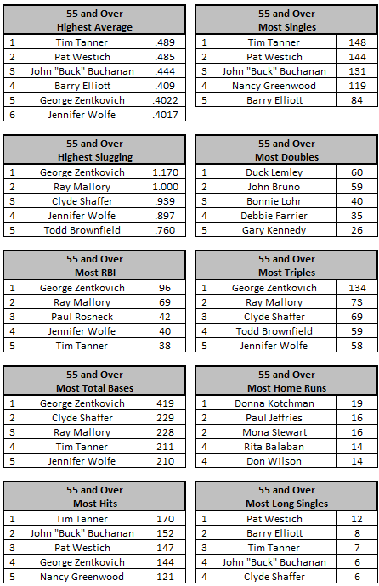

INDIVIDUAL LEADERS BY CATEGORY

2023-2024

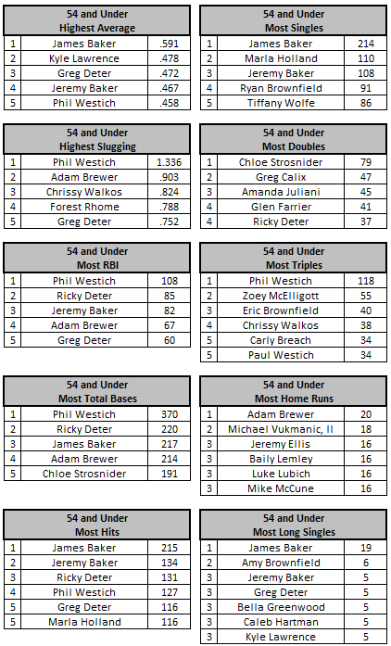
LEAGUE LEADERS BY CATEGORY

Most At-Bats – James Baker (Jefferson Baptist #1) – 364
Highest Batting Average – James Baker (Jefferson Baptist #1) – .591
Best Slugging Percentage – Phil Westich (Bible Baptist) – 1.336
Most RBI's – Phil Westich (Bible Baptist) – 108
Most Total Bases – George Zentkovich (Jefferson Baptist #1) – 419
Most Hits – James Baker (Jefferson Baptist #1) – 215
Most Singles – James Baker (Jefferson Baptist #1) – 214
Most Doubles – Chloe Strosnider (Crosspoint Assembly Of God) – 79
Most Triples – George Zentkovich (Jefferson Baptist #1) – 134
Most Home Runs – Adam Brewer (Hewitt Presbyterian) – 20
Most Long Singles – James Baker (Jefferson Baptist #1) – 19

2024 HALL OF FAME INDUCTEES

Todd Brownfield – Oak View Methodist

John Bruno – Waynesburg Methodist

Nancy Greenwood – Greensboro Baptist

Marla Holland – Oak View Methodist

Tiffany Wolfe – Jefferson Baptist #2

500 CLUB

James Baker – Jefferson Baptist #1

400 CLUB

Jeremy Baker – Jefferson Baptist #1
John “Buck” Buchanan – Greensboro Baptist
Greg Deter – Greensboro Baptist
Barry Elliott – Hewitt Presbyterian
Marla Holland – Oak View Methodist
Kyle Lawrence – Jefferson Baptist #2
Tim Tanner – Greensboro Baptist
Pat Westich – Bible Baptist
Phil Westich – Bible Baptist
Jennifer Wolfe – Jefferson Baptist #2
George Zentkovich – Carmichaels Methodist #2

INDIVIDUAL TROPHY WINNERS

LEAGUE LEADERS (ALL AGES)

Highest Average James Baker .591

Best Slugging Percentage Phil Westich 1.336

Most RBI’s George Zentkovich 96

Most Total Bases Clyde Shaffer 229

Most Hits Tim Tanner 170

Most Singles Pat Westich 144

Chas Sands Memorial Trophy (Most Doubles)

Chloe Strosnider 79

Most Triples Ray Mallory 73

Most Home Runs Adam Brewer 20

Most Long Singles Barry Elliott 8

AGE 55 AND OVER

Highest Average Jennifer Wolfe .402

Best Slugging Percentage Todd Brownfield .760

Most RBI’s Paul Rosneck 42

Most Total Bases Donald “Duck” Lemley 200

Most Hits Nancy Greenwood 121

Most Singles Dennis Tucker 50

Most Doubles John Bruno 59

Most Triples Terry Cox 48

Most Home Runs Donna Kotchman 19

Most Long Singles Terrie Tanner 4

INDIVIDUAL TROPHY WINNERS

AGE 54 AND UNDER

Highest Average Marla Holland .446

Best Slugging Percentage Chrissy Walkos .824

Most RBI’s Jacob Robison 46

Paul Westich 46

Most Total Bases Zoey McElligott 179

Most Hits Tiffany Wolfe 92

Most Singles Peter Westich 66

Most Doubles Greg Calix 47

Most Triples Eric Brownfield 40

Most Home Runs Michael Vukmanic, II 18

Most Long Singles Amy Brownfield 6

AGE 15 AND UNDER

Highest Average Nathan Westich, Jr. .265

Best Slugging Percentage William Westich .585

Most RBI’s Bella Greenwood 45

Most Total Bases Andrew Westich 136

Most Hits Bowen Durr 49

Most Singles Matthew Parker 10

Jason Wolfe 10

Most Doubles Alexis Vukmanic 24

Most Triples Aeris Blake 15

Most Home Runs Baily Lemley 16

Most Long Singles Michael Vukmanic, III 4

